LOGO AND BRAND NAME


LANDING PAGE
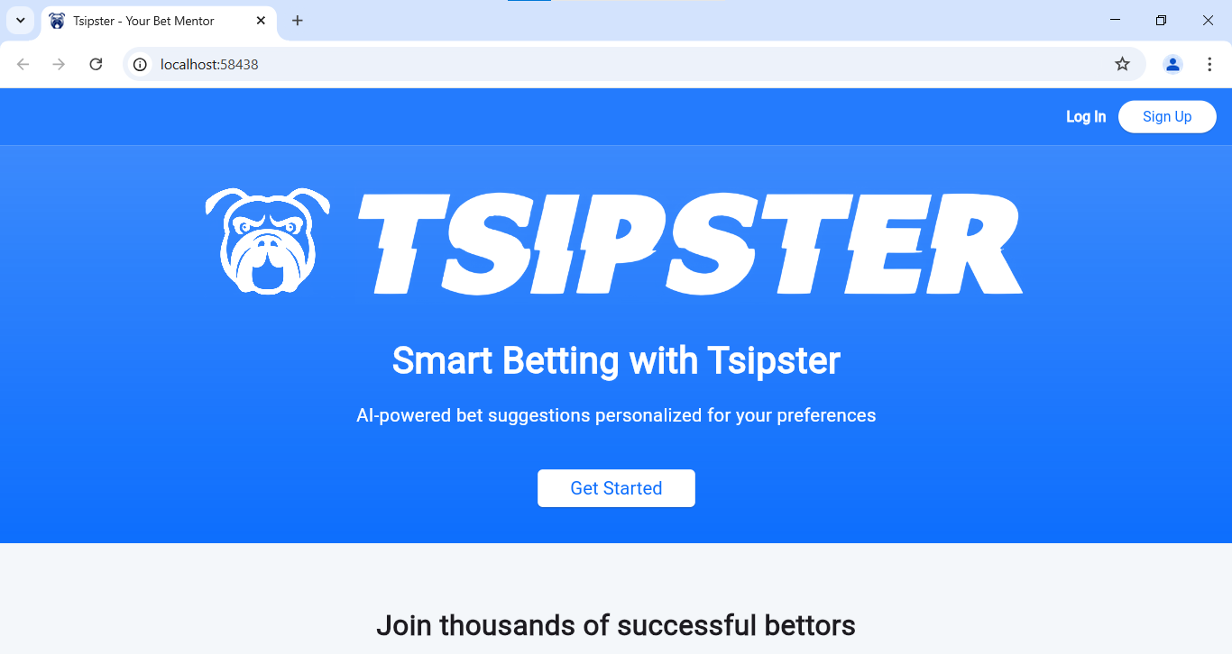
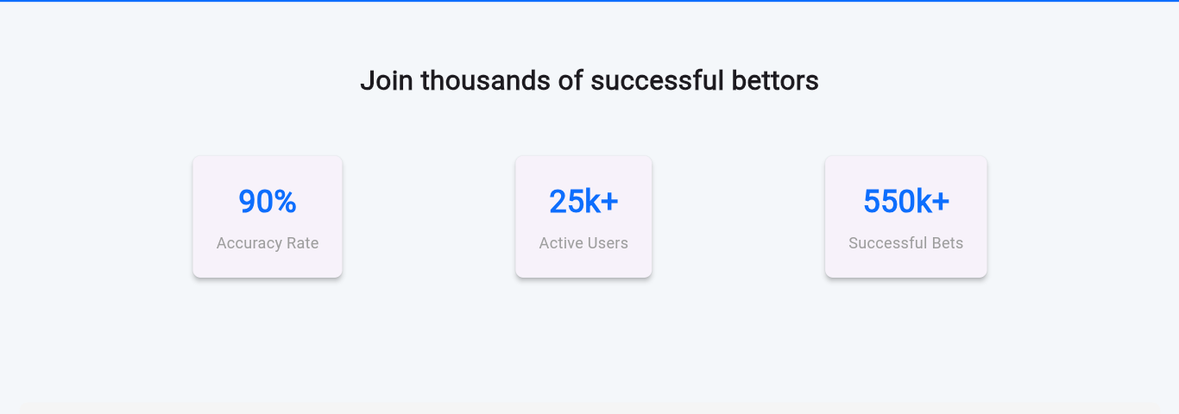
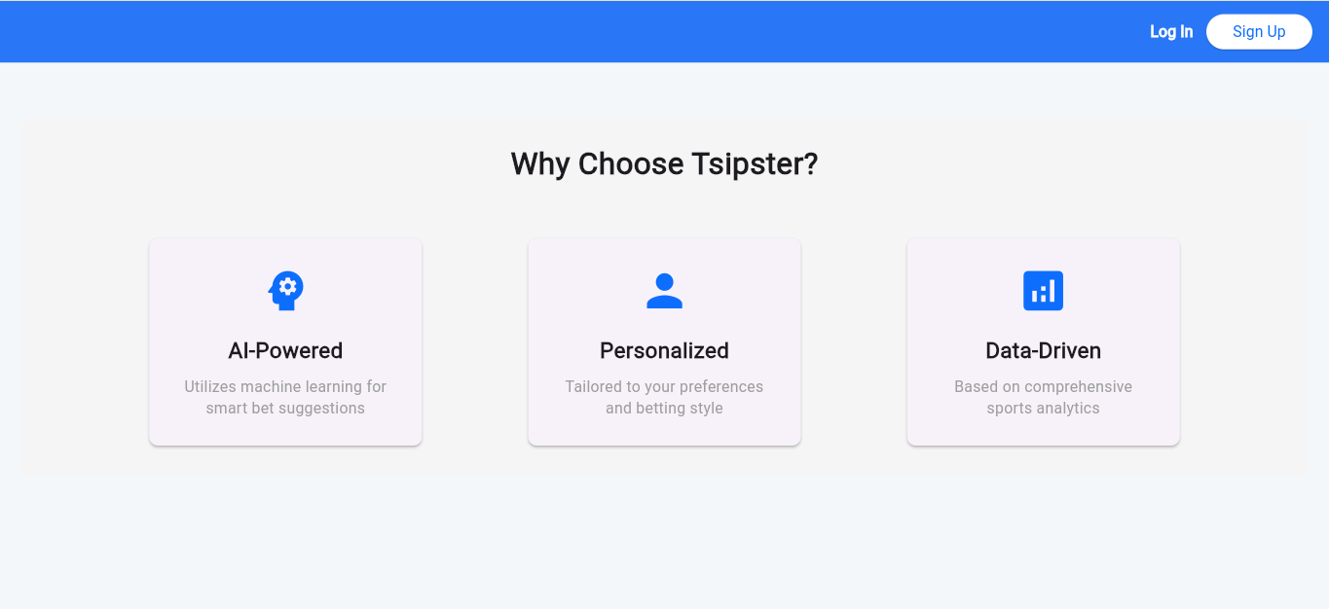
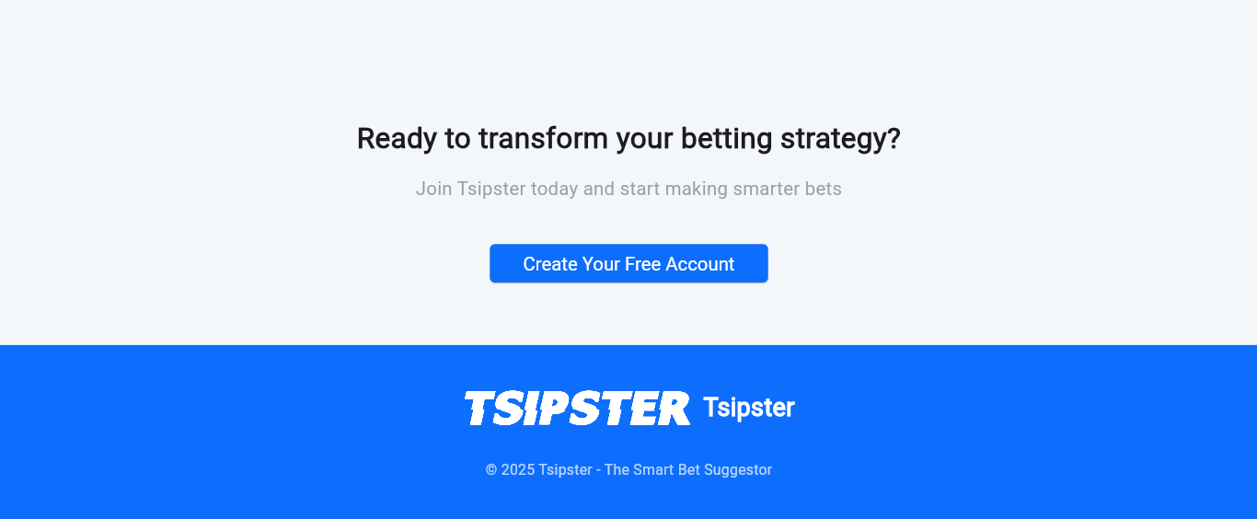
SIGN UP PAGE
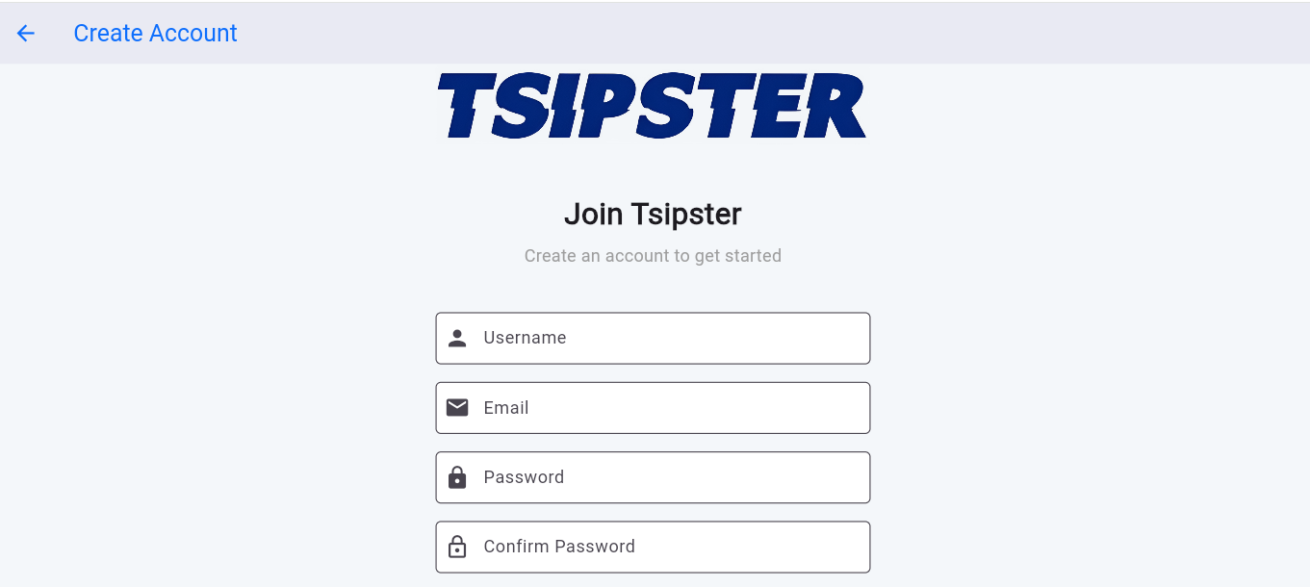

VALIDATION CHECKS
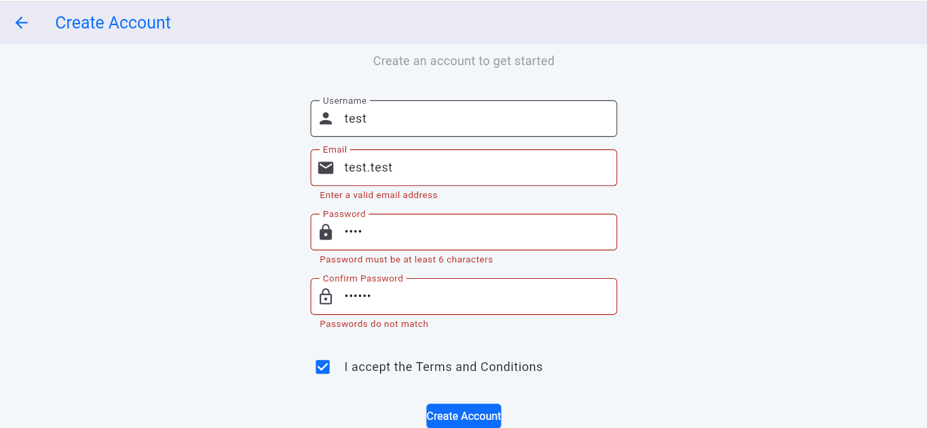

ON-BOARDING PAGE
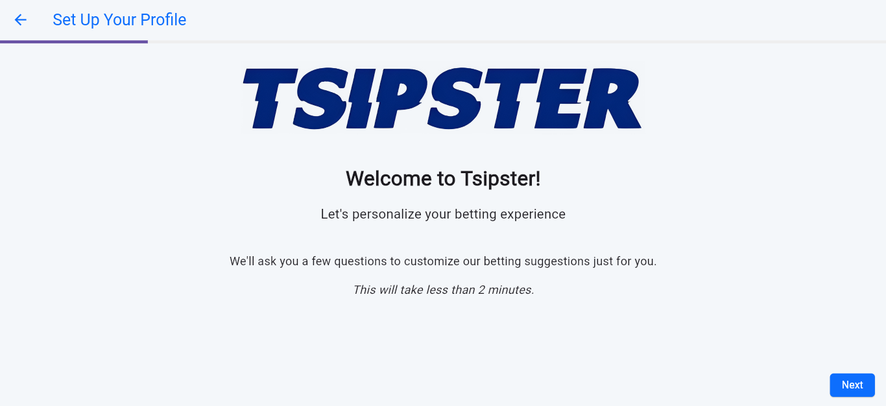
USER SETS HER/HIS BET TYPE PREFERENCES
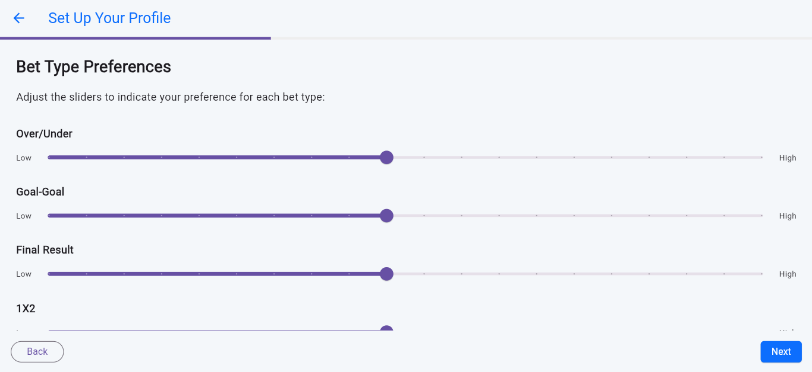USER CHOOSES THE LEAGUES SHE/HE WATCHES THE MOST
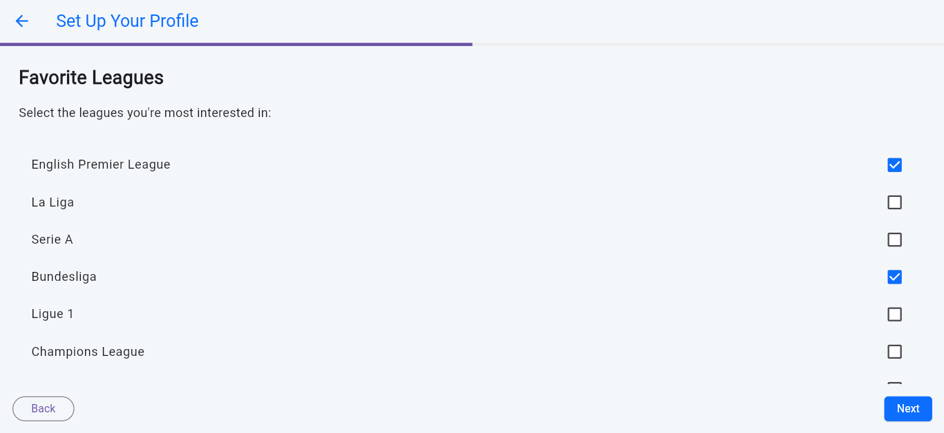
USER SETS THE PREFERRED RISK TOLERANCE
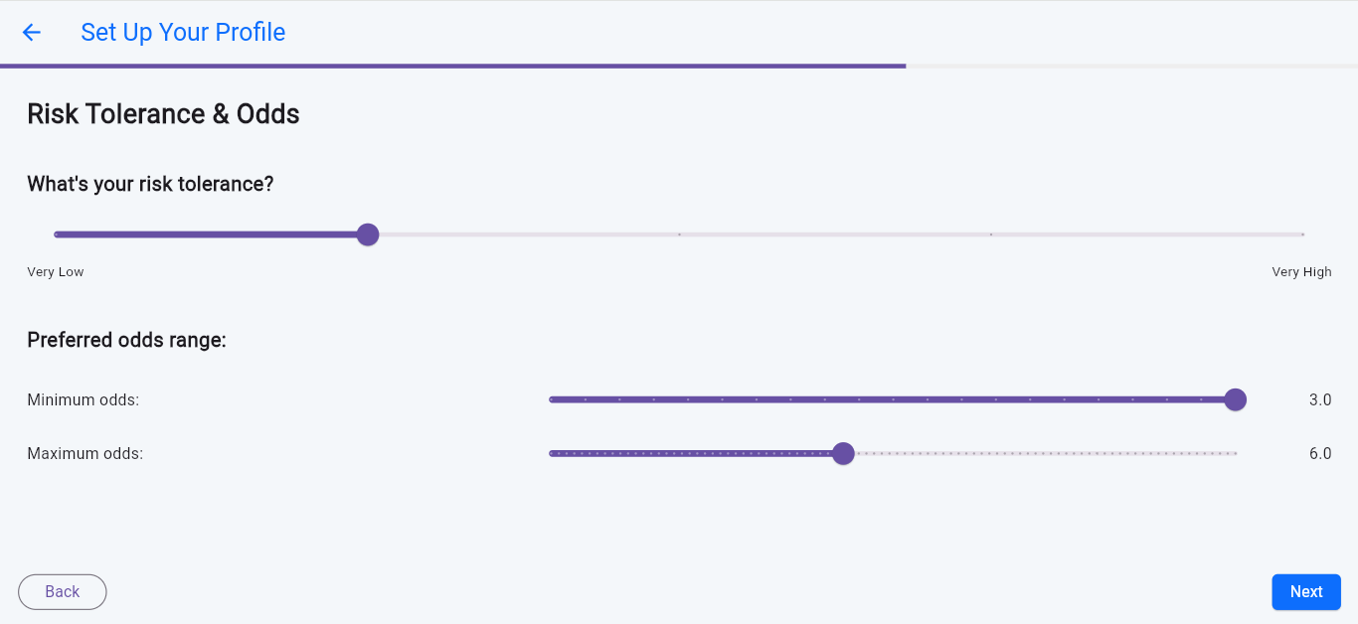

USER CAN ADD HER/HIS FAVORITE TEAMS
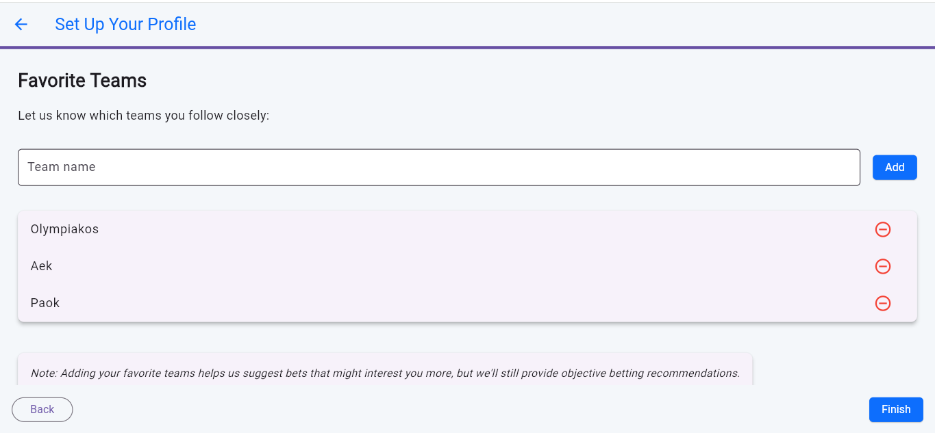

BETTING SLIP CREATION PAGE
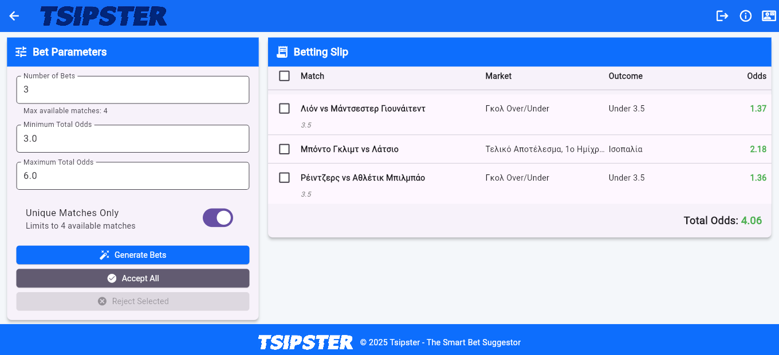
USER CAN MODIFY THE SUGGESTED BET SLIP, BY REJECTING AN OPTION
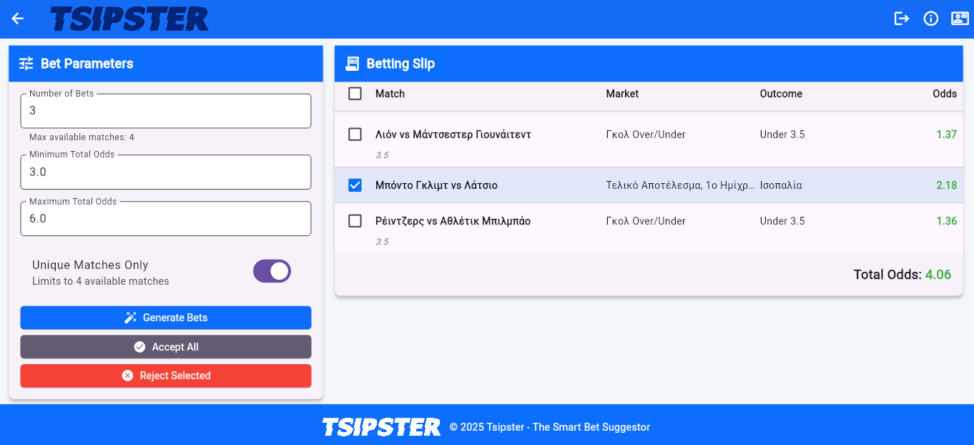
NEW OPTION GENERATES, KEEPING THE OTHER BETS AS THE USER WANTS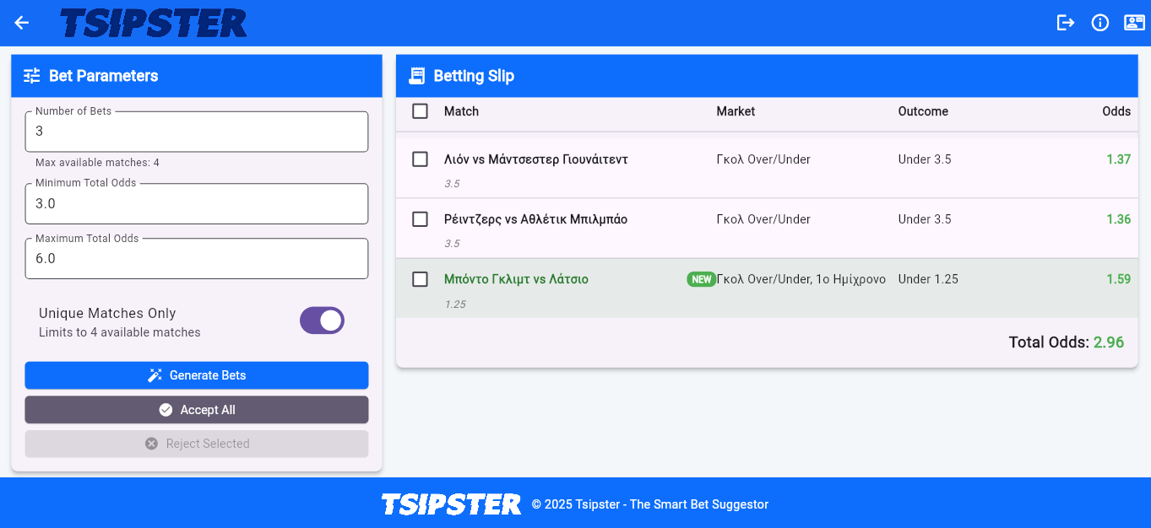
VERSION CONTROL
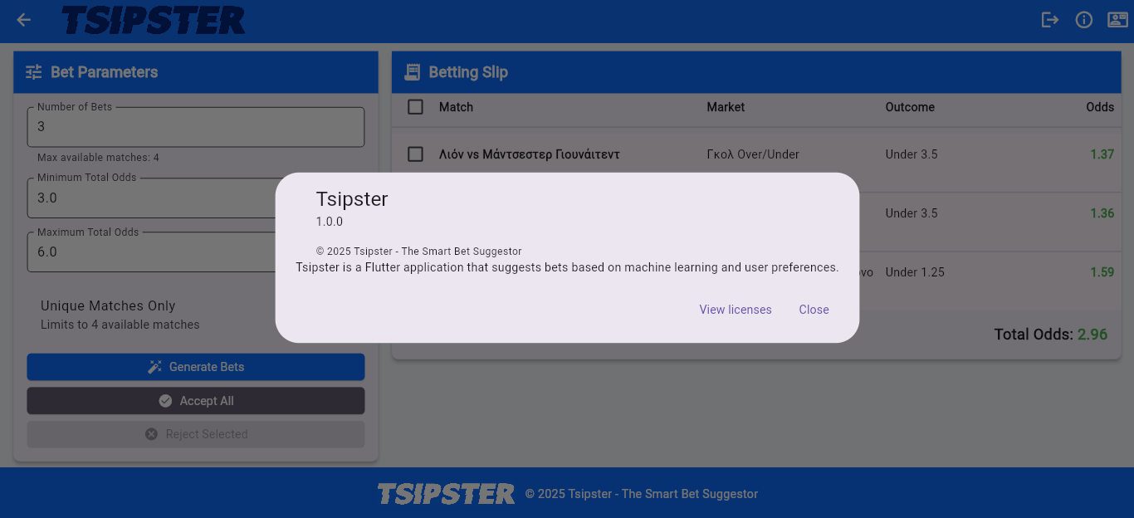

Note
Tsipster’s User Interface (UI) is still under development, for Android / iOS support

